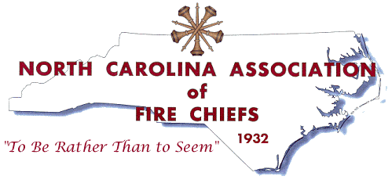
North Carolina Association of Fire Chiefs
Fire Officer of the Year Award
Nomination Cover Page
(Please submit with nomination material)
Nomination Category

Career: ________________ (includes full-time employment in a combination department)

Volunteer: ______________
Region: ______________
Nominee: _______________________________________________________________
Fire Department: __________________________________________________________
Address: _________________________________________________________________
City/State/Zip: ____________________________________________________________
Telephone: __________________________Email:________________________________
Person/Region submitting the nomination:
Name: ______________________________Signature_____________________________
Organization/Region: _______________________________________________________
Address: _________________________________________________________________
City/State/Zip: ____________________________________________________________
Telephone: __________________________Email:________________________________
Please use the outline below to categorize the nominees experience and accomplishments when submitting nomination information:
- Fire Service Experience - List the nominee’s Fire Service experience including length of service, departments in which he/she has served and position’s held. Emphasis should be given on the time the individual has served as chief.

- Education - Provide a summary of the nominee’s formal education and Fire Service training/education achievements.

- Professional Development- Provide a narrative describing examples of the individual’s professional development, professional contributions, and association memberships.

- Community Involvement - Describe the individual’s contributions to his/her local community.

- Fire Service Involvement/Contributions - Describe the individual’s contributions to the fire service community.

- Character – Confirm that the individual is free of characteristics that would discredit the NCAFC such as having a criminal history. If there is a criminal history, please explain.

The Fire Officer of the Year Award will be presented at the NCAFC Mid Winter Conference Banquet to be held Saturday night February 2, 2019 at The Embassy Suites and Concord Convention Center, Concord, NC
All nominations must be type-written and postmarked by December 31, 2018, to: NCAFC, P.O. Box 1416, Shelby, NC 28151. For questions, call (980) 522-6129.

